Win FREE tuition to the Wilmington Safety School!

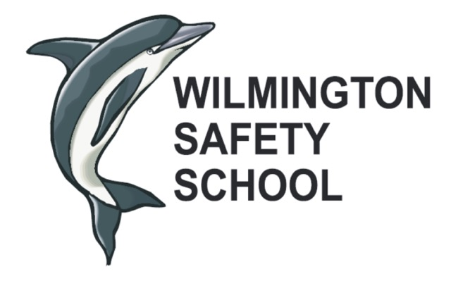 | www.wilmingtonsafetyschool.com

Established in 1950, the Wilmington Regional Safety and Health School is a non-profit organization committed to bringing important safety and health information to the public.
The scholarship program is open to all undergraduates who are currently enrolled in at least 12 credit hours per semester and who have at least one year of study remaining in their degree programs. To be considered for the award, students must meet the following requirements: 1) be enrolled in a two or four year technical or college program in North Carolina in Environmental Studies, Safety and Health, or related field, 2) complete this application form, 3) write and submit an essay (see Section II).
The application and essay must be placed in the same envelope and mailed by June 10th to the address below. Any additional, extraneous materials (photos, resumes, research materials, etc.) will not be considered and will be discarded. The Wilmington Regional Safety and Health School will select the recipient and notify him or her by phone and U.S. Mail.
(Please use an address where you can always receive mail)

Student Information
Last | First | Middle
Street |  | City
State | Zip | Phone
College or University Information
School Name
School Address
Program Applicant is enrolled in
Signature

Section II (Essay must be written by Student and must accompany completed application)
The essay must have the applicant’s full name and the school name at the top of the page, centered in a header, and must be a maximum of one page in length, single-spaced, with 1” margins and a font size of 10. Handwritten submittals will not be accepted and will automatically disqualify the applicant.

Essay question:
“Describe a health, safety or an environmental issue relevant to your university or college. Examine and discuss what actions and/or programs are needed to solve this issue.”

E-mail to: notifications@wilmingtonsafetyschool.com  Or mail all documents  Together and postmarked  by June 10th to: | Wilmington Regional Safety and Health School  P.O. Box 25  Wilmington, NC 28402
See www.wilmingtonsafetyschool.com for more information

Note: The postmarked deadline for applications is June10th.
Packages postmarked after that date will NOT be considered.

